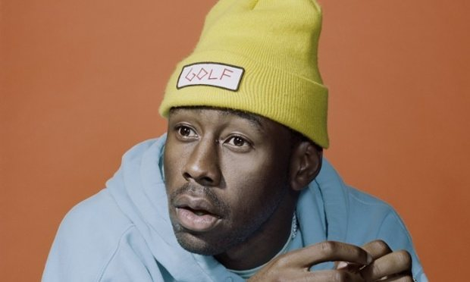Wolfenstein: New Order is the first Wolfenstien game to be released in Germany (Rawlinson, 2014), with the game being based around the Nazi party it isn’t surprising that it’s banned as all Nazi symbolism banned in the country since World War 2. In the German version, the Nazi’s were replaced with a force called The Regime. Not censoring content can even lead to individuals being banned from countries rapper ‘Tyler, the Creator’ has been banned from entering the UK, New Zealand and Australia due the nature of his lyrics, the NZ government stopped him entering for posing “a threat to the public order and the public interest” (Shepard, 2015).

# References

# Kevin Rawlinson, 2014, *Wolfenstein has first German release with the New Order,* <http://www.bbc.co.uk/news/technology-27488254> *[Accessed 14/11/16]*

Julianne Escobedo Shepard, 2015, *Tyler, the Creator on being banned from the UK: ‘I’m being treated like a terrorist’,* <https://www.theguardian.com/music/musicblog/2015/sep/01/tyler-the-creator-comments-banned-uk-freedom-of-speech> [Accessed 14/11/16]